# Transaction Matrix (Data entry)

1. Enter details of a new user

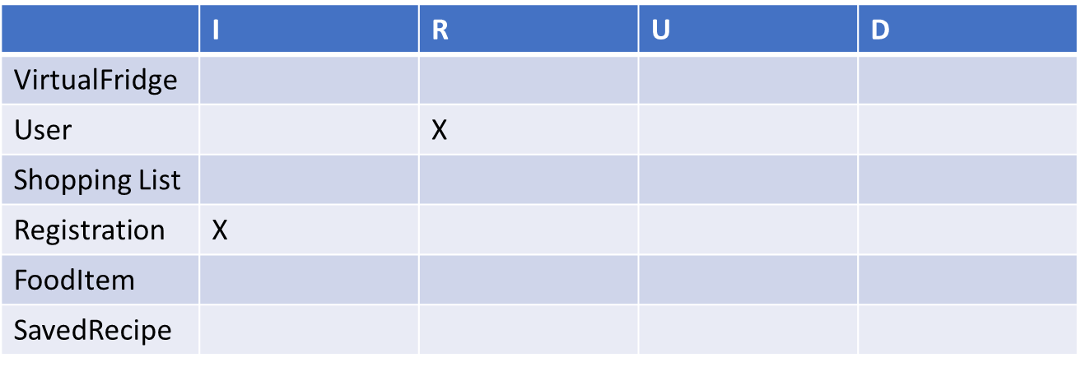

1. Adding new ingredient to Virtual Fridge

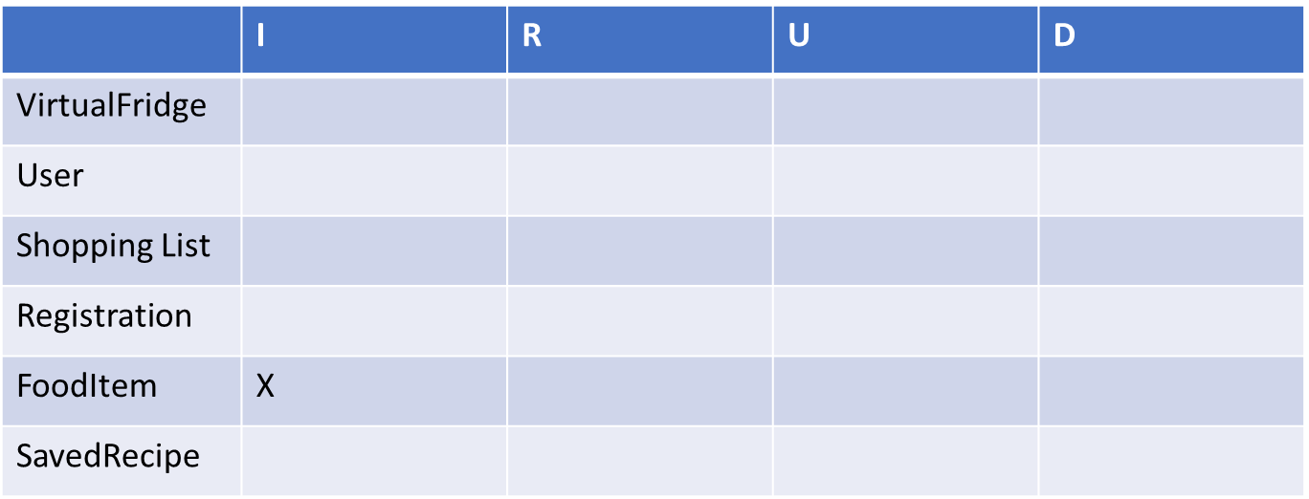

1. Uploading a new recipe

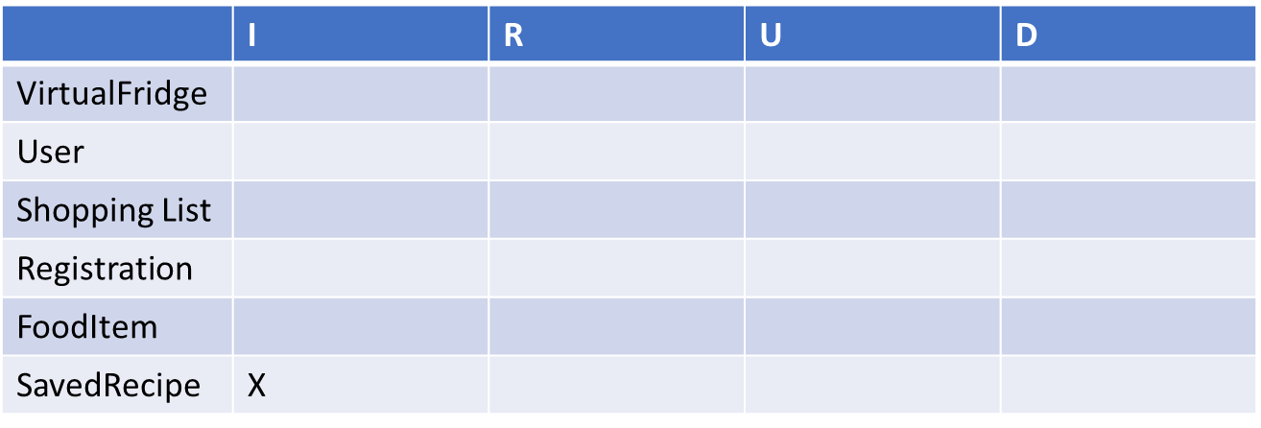

1. Adding an item to the shopping list

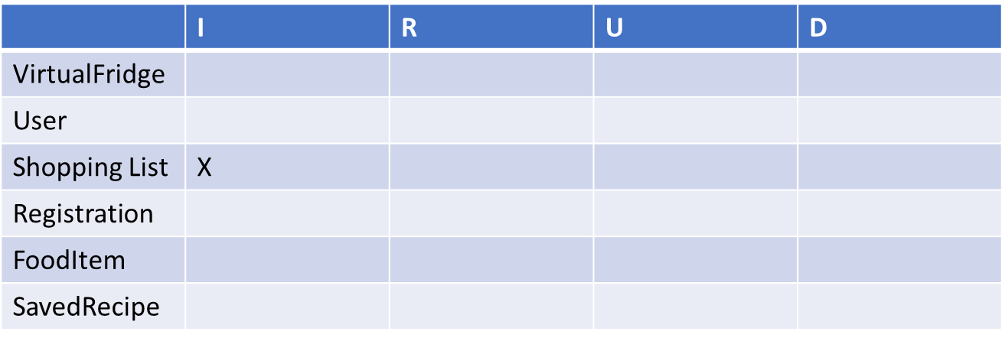

1. Add a comment on a recipe

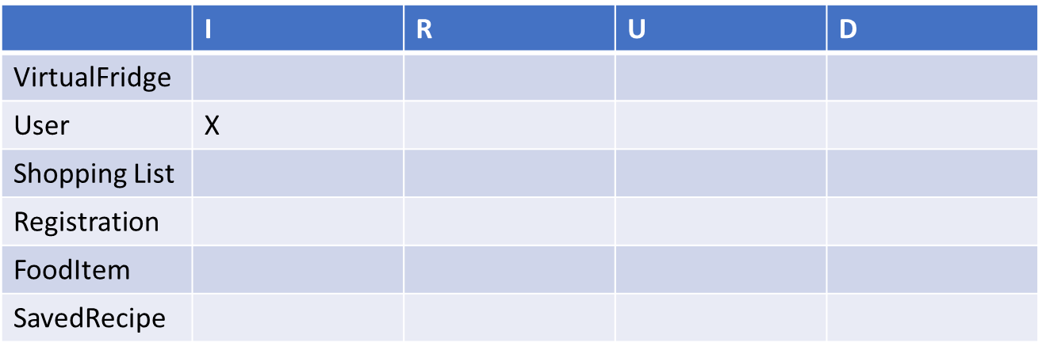

# Transaction Matrix (Deletion/Updates)

1. Update/Delete Recipe

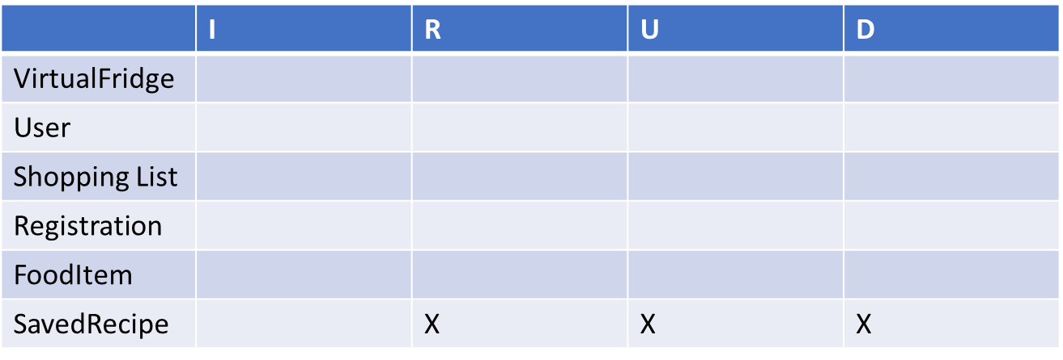

1. Delete/Edit comment

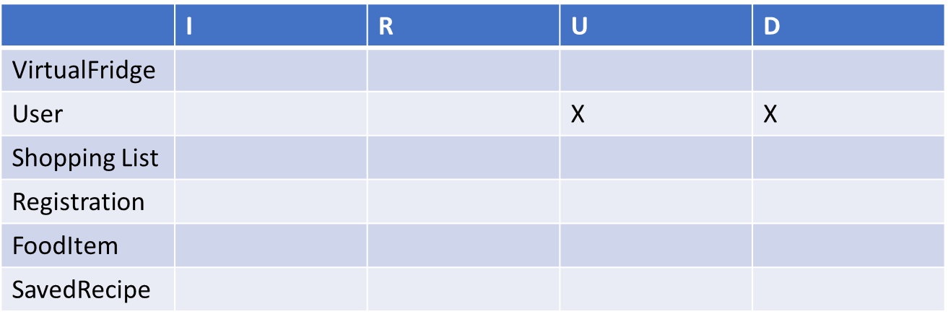

1. Delete User

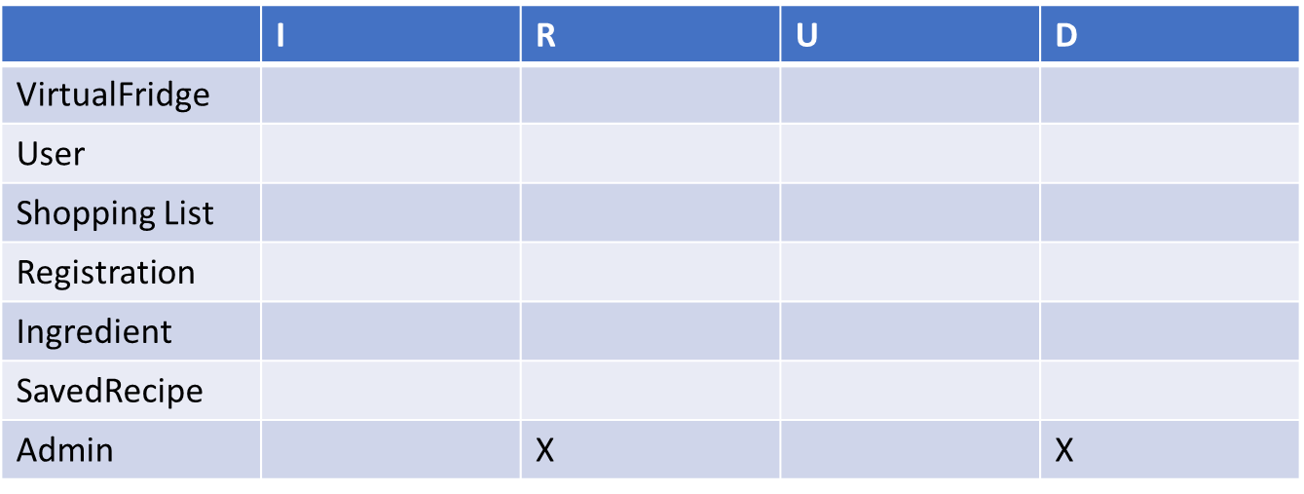

1. Update shopping List

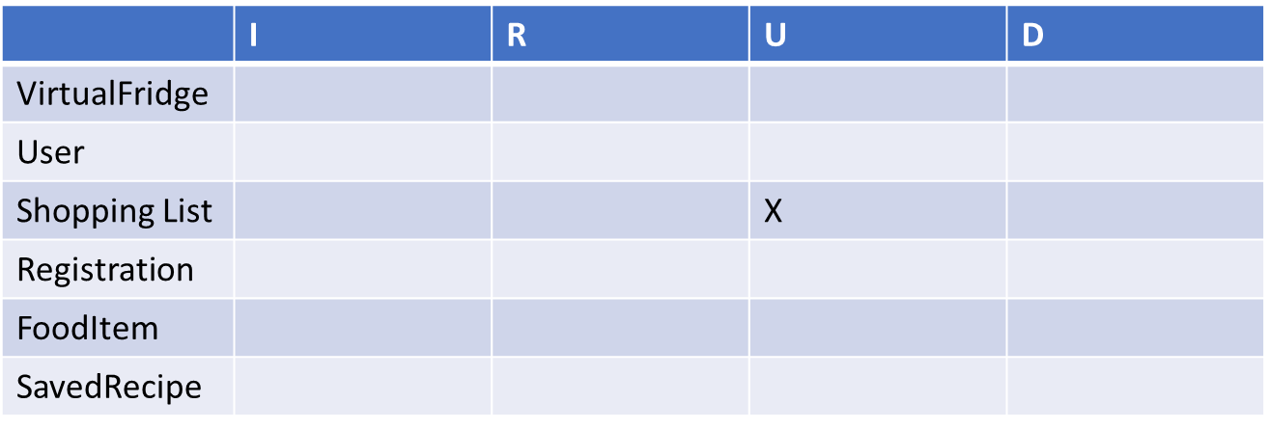

# Transaction Matrix (Data Queries)

1. List recipe details/comments on a recipe

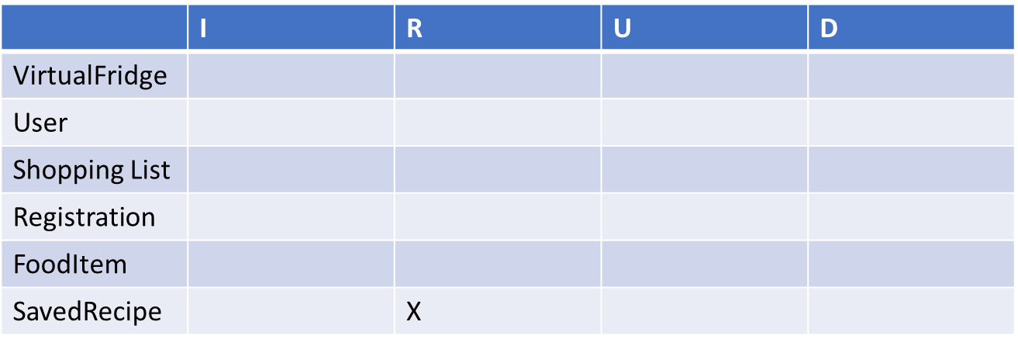

1. List virtual fridge items/ingredients

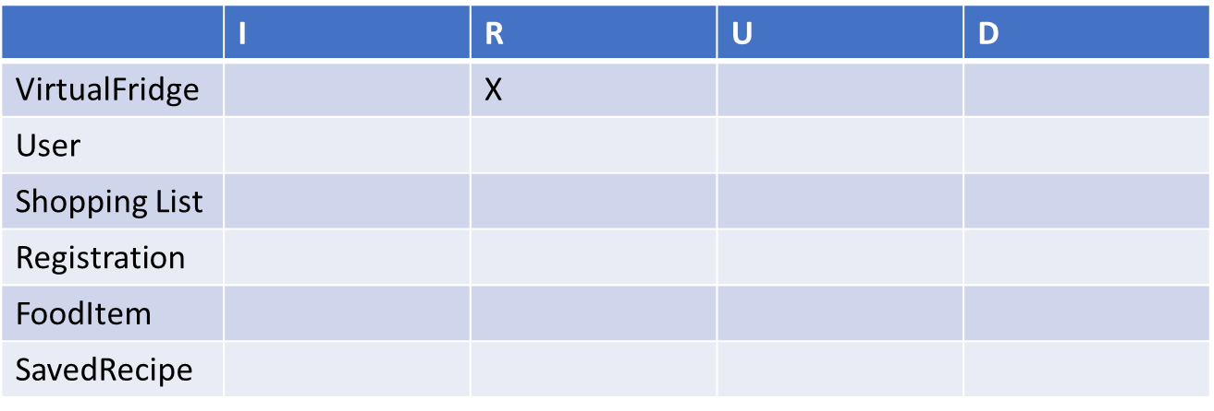

1. List shopping list

